Amazon Product Review Data Analysis
CIS 5200-3
Group 2
Jaydeep Chopde, Maitri Shah, Monika Mishra, Pankti Parikh, Rakshith Chandan Babu

Abstract: This paper aims to analyze the various shopping patterns and customers’ sentiments based on reviews and ratings provided by the customers on the online amazon shopping site. The product reviewed is from four countries i.e. US (United States), UK (United Kingdom), FR (France), DE (Germany) between the year 2005 and 2015. The dataset used for this paper is from an open data source of the Amazonaws site. The total file size is 5.26 GB. The file format is a mix of Tab Separated Values (TSV) and Comma Separated Values (CSV). From the available data we found about the customers’ sentiments using text analysis. We also found the shopping patterns by factors such as year, month and product category. Additionally, we also found popular product based on average rating and review count. Eventually, we will present valuable insights that is extracted from the dataset.

- Introduction
The online shopping is in trend these days. With the quick growth of internet and it’s increasing accessibility, e-commerce has developed rapidly in the last few years. With the introduction of e-commerce shops, we can buy anything with a click of the mouse. Though it has many advantages, it has few shortcomings too. The biggest disadvantage of e-commerce is that one is not able to see and feel the product. Since consumers are not able to feel and touch the product, most of the customers, on any online shopping sites, make purchasing decisions based on reviews and ratings. Therefore, it’s very important for the business to know the various shopping patterns and customer’s sentiments based upon the reviews and ratings. Among all this, we analysed the reviews from four countries United States, United Kingdom, France, Germany between year 2005 and 2015.

- System Specification
To begin work on this dataset, we used services offered by Oracle cloud. We extensively worked on Hadoop system components. The Hadoop cluster details are given below:

Cluster Version – Oracle Big Data Compute Edition
Number of Nodes – 5
Memory size – 150 GB
CPU – 20 vCPU
CPU speed – 2.20 GHz
HDFS capacity – 147 GB
Storage – 678 GB

III. Architecture Workflow

We extracted the product review data for the country US, UK, DE, FR in TSV format from amazonaws site. As the reviews were in various languages, we also downloaded the English (TSV), German (TSV) and French (CSV) dictionaries. Then, we uploaded our data to the HDFS and used Hive queries to create external tables based on the data that was uploaded in HDFS. We then triggered Hive queries to analyze the data. For the visualization purpose, we used Tableau, Power BI and Excel 3D maps. At the end we found useful insights.

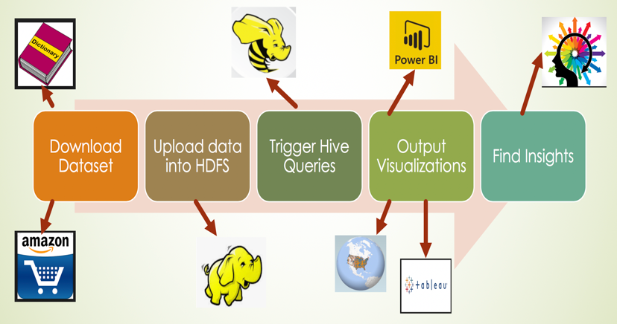

Figure 1: Flow diagram

- Data Analysis/Visualizations
After performing the workflow that is mentioned in the figure 1, we got the following results below for rating. We present our findings in an appropriate chart.
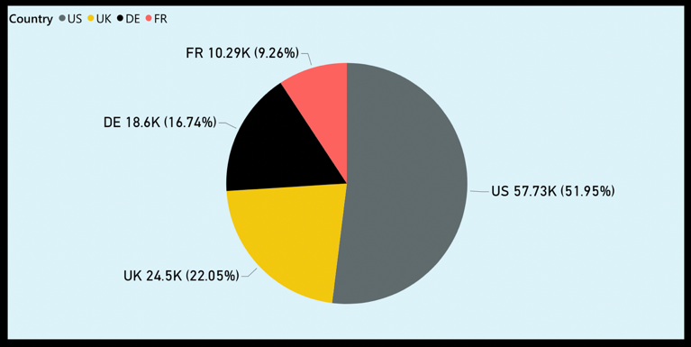
Figure 2: Total review sentiment count by country
From the pie chart above, it shows that the overall sentiment count is maximum for USA which is 57.73K (51.95%) followed by UK (24.5K - 22.05%), Germany (18.6K - 16.74%), France (10.29K - 9.26%) between the year 2005 and 2015.
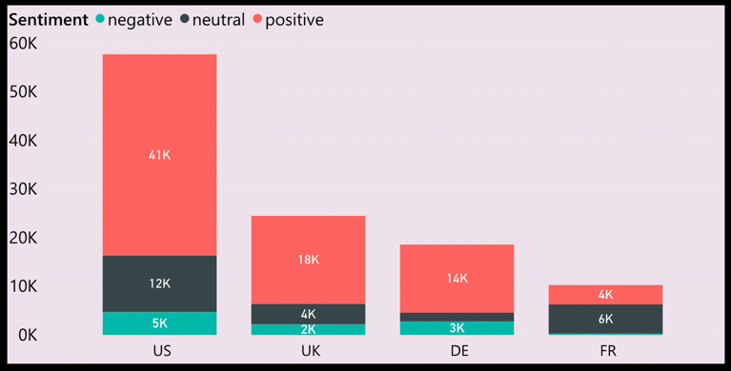

Figure 3: Sentiment analysis by country

The bar chart above shows the distribution of review sentiment - negative, neutral and positive among US, UK, DE and FR. It can be seen that all the countries except France have comparatively a positive view about the amazon products. Also, US has the maximum sentiment count followed by UK, Germany and France.
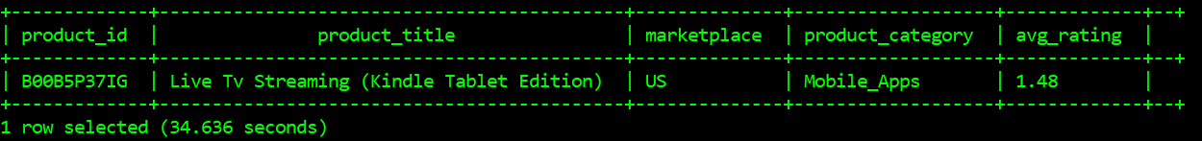
Figure 4: Least rated product

Taking the results of the previous sentiment chart, we targeted US to get into more details about which product was least graded and we found the result as Live Tv Streaming (kindle table Edition) which has average rating of 1.48. When looking for least reviewed product we considered only the product which had more than 50 reviews

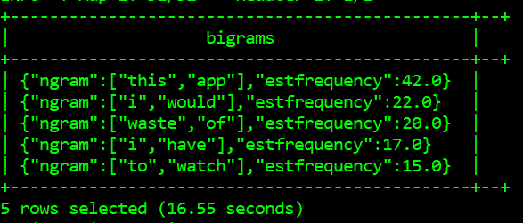
Figure 5: Common words that were used in the reviews of Live Tv Streaming - bigram

The above figure shows the sentiment analysis using bigram of the least rated product - Live Tv Streaming (kindle table Edition). But using bigrams, the result was not clear.
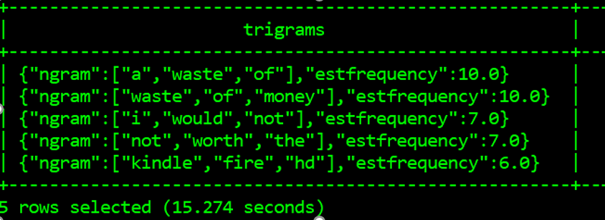
Figure 6: Common words that were used in the reviews of Live Tv Streaming - trigram

We moved towards trigrams to get a clear picture on the users’ sentiments. It was found that ‘waste of’ was commonly used words to describe the product.

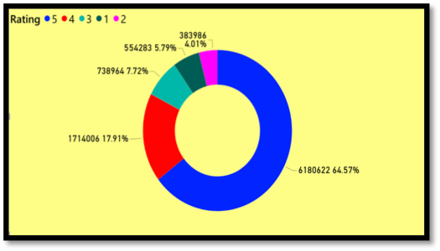
Figure 7: Distribution of overall ratings for Amazon products
The donut chart above shows the distribution of rating from 1 to 5 (5 being the maximum) on the amazon site of amazon products. It can be seen that the rating 5 has the maximum count (64.57%) followed by 4 (17.91%), 3 (7.72%), 1 (5.79%) and 2 (4.01%). So, it can be said that the customers are quite happy with the products that they buy from amazon.

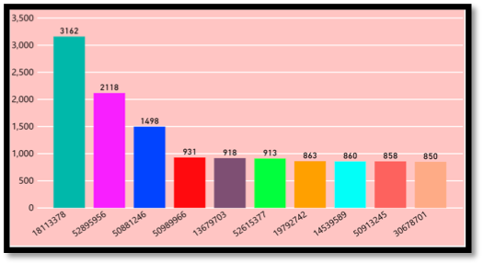

Figure 8: Number of reviews given by unique users over ten years

The column chart above shows the number of reviews given by unique users over ten years which indicates that amazon has customers who are not just using the products but also prefer to give reviews regularly as one of the users has given the review more than 3k over a span of ten years.
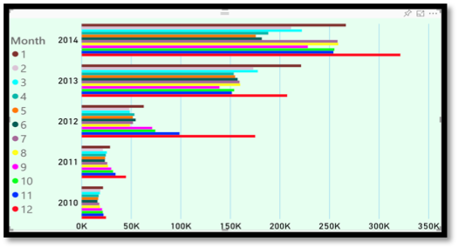
Figure 9: Review count by year and month

The bar chart above shows the reviews count by year (2010 to 2014) and month (January to December). From the above chart, it is clearly visible that the review count has significantly increased from 2010 to 2014. Also, the review count is more in the holiday months (November, December, January) as compared to other months.
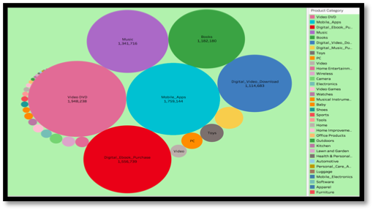

Figure 10: Review count by product category

The chart above shows the review count as per the product category which indicates that Video DVD was the maximum reviewed product which is 1,948,238. Then comes mobile apps with 1,759,144 and then the Digital_ebook_Purchase with 1,556,739 and so on. It can be seen that overall digital products have received more reviews than the non-digital products.
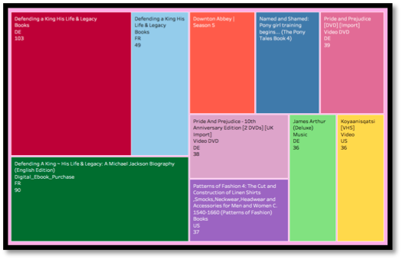
Figure 11: Popular product based on average rating and review count
The tree map reveals top 10 most popular product among the users based on user’s average ratings and reviews. It can be concluded that Books is the most popular category. Among them Defending a king his life and legacy is top most trending book, which has the highest number of ratings and reviews. The same book is popular in the Digital e-book category as well.
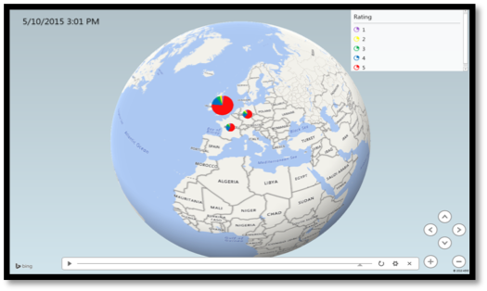
Figure 12: Rating based geospatial representation for product category-baby

The 3D excel power map shows that the product category “Baby” has received maximum rating (5) followed by 4, 3, 2, 1 in all the countries. This shows that users are overall happy with the baby products. Another thing which can be noticed is that the rating count has gradually increased over the years.

- Summary of insights:

- Books is the most popular category based on ratings and reviews.
- Around 3,162 reviews(maximum) were written by one user in the span of 10 years.
- The review count has gradually increased over the years.
- The review count is maximum in the holiday months – November, December, January.
- 64.57% people gave the maximum rating 5 to the products.
- Video DVD received the maximum number of reviews.
- The consumer sentiments are mostly positive in US, UK and Germany country.
- Digital products have received more reviews than the non-digital products.

- Github URL

https://github.com/monika2403/mmishra2

- Data source URL

https://s3.amazonaws.com/amazon-reviews-pds/tsv/amazon_reviews_multilingual_US_v1_00.tsv.gz
https://s3.amazonaws.com/amazon-reviews-pds/tsv/amazon_reviews_multilingual_DE_v1_00.tsv.gz
https://s3.amazonaws.com/amazon-reviews-pds/tsv/amazon_reviews_multilingual_UK_v1_00.tsv.gz
https://s3.amazonaws.com/amazon-reviews-pds/tsv/amazon_reviews_multilingual_FR_v1_00.tsv.gz
https://s3.amazonaws.com/hipicdatasets/dictionary.tsv
http://www.ulliwaltinger.de/ment/GermanPolarityClues-2012.zip
https://advance.lirmm.fr/FEEL.csv

